MiCo 2026 RP-1 QUICKSTART AND OVERVIEW

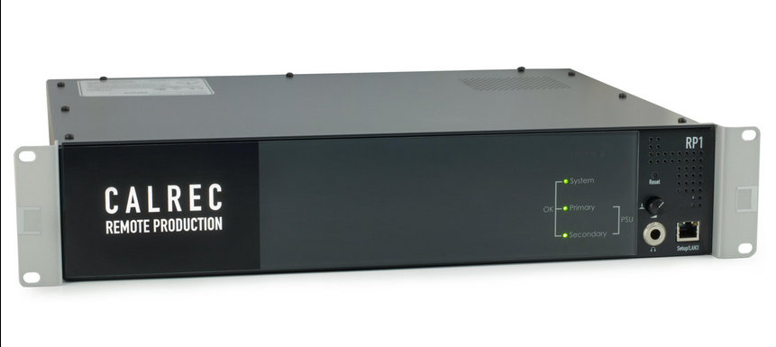

**OVERVIEW**

This document provides a brief description of what

the Calrec RP-1 is, and how the Olympics Audio Team plans on deploying and utilizing these units for the MiCo 2026 Games.

The RP-1 (remote production) is essentially a Calrec console within a two space rack unit, there is no physical surface with faders but instead a graphic user interface that can be navigated to through Google Chrome. The RP-1 can connect

back to a “host” Artemis or Apollo Calrec console which then gives the host console the ability to remotely control the Calrec RP-1 Unit. This connection allows the host mixer and off-site A1 to make the Calrec RP-1 act as an extension of the Artemis or Apollo console being used to mix the production. This configuration is necessary to provide a zero latency IFB mix to on-site announcers and additionally gives more control and independence to the off-site A1 in regards to things like gain control, signal processing, and routing to transmission.\

Each RP-1 unit has 3 IO card slots on the rear of the device, which are labeled C (Top), D (Middle),and E (Bottom) respectively; for the 2026 Games there will always be a Calrec Dante Card in the C slot and two Calrec Madi Cards, one in each of the D and E slots. For further connectivity, the RP-1 has primary and secondary Hydra fiber ports to connect to Calrec fixed format Analog, Madi, AES, or Modular Frames. Please note that only a single Hydra Box can be connected to an RP-1 unit directly, if more Hydra boxes are needed a Calrec H2 Hydra Hub Router will need to be used to facilitate multiple Hydra Box connections into the RP-1's primary and secondary LC Hydra Ports. Both redundant power supplies need to be connected at all times or the RP-1 will display an error code. 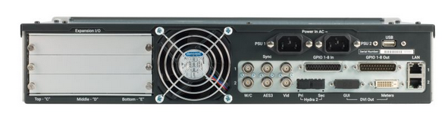

There are two ethernet ports on the rear of the RP-1 units labeled LAN1 and LAN2, LAN1 will always need to be connected to an NBC Venue or Admin switch and LAN2 has no currently planned use. The LAN1 connection provides the data connection circuit back to the host console, both the GUI interface and the host console’s data connection use the same IP address which during the MiCo 2026 Games will be a 100.127.XXX.XXX address. The RP-1 can be accessed locally or in a troubleshooting scenario by connecting to the LAN3 port on the front of the unit, this address will always be 192.168.1.1 and can be accessed with any computer on that network using the LAN3 connection port and a Google Chrome web connection.

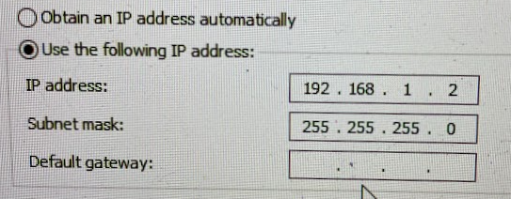

If the 192.168.1.1 does not load from LAN 3 then ensure the URL prefix is ‘http’ and not ‘http**s**’

There are also coaxial connections for video sync connections. Blackburst from a mobile unit or a broadcast TOC area should be connected to the VID1 input - the sync settings and priority can be set from the synchronization menu within the GUI. There is also a DVI output on the rear of the RP-1 which will output a view of the metering screen, this is especially important for the local view of the input levels at the flypack venues where there are no mobile units.

The RP-1 unit has 32 channels of DSP which can create 32 mono legs of an audio signal (stereo channels use 2 DSP channels and 5.1 channels use 6 DSP channels); the expanded and upgraded RP-1 units can have up to 96 channels of DSP. The unit includes a 36 fader virtual surface with the familiar Calrec A fader and B fader set up, gain/trim settings for every input as well as basic equalizer and dynamics processing. The only place where the RP-1 is fairly limited is the output section. There are fader direct outputs that can be created for every input DSP channel, but the only mixed outputs are 12 auxiliary outputs - these can be set as mono or stereo outputs up to 12 mono legs (24 auxes on the upgraded and expanded RP-1s). For the MiCo 2026 Olympics pre-fader direct outputs are used to feed the TOC or Mobile Unit Router over Madi which then feeds the TX paths back to Stamford. The Auxiliary outputs are used to create any mixed signals like IFB programs, local program feeds, cameras feeds and any other mixes reliant on the on site audio resources.

The remainder of this document does not focus on the deep functions of the RP-1 but more of the unit's connection needs, general capabilities, and use cases in regard to the Olympics Audio set-ups.

**SIGNAL FLOW**

While the RP-1 and its resources are incredibly flexible, Olympics Audio is using these facilities in a fairly systematic way, and while there are exceptions, there are a few standard consistencies across all deployment regarding the RP-1’s on board card slot IO.

“C” Slot Dante Card traffic - All IO traffic to and from the RP-1 is routed through this card

* Model 234 unit inputs
* Model 381 unit inputs
* All outputs to and inputs from Odin or Adam M intercom systems.

“D” Slot Madi Card traffic - both the Madi in and out connections should be made on each card either through coax or fiber- Be aware of the toggle switch on the rear of these Calrec cards which change the input type being used. The output will transmit on both Coax and Fiber but the input must be intentionally selected based on use case.

* Outputs to mobile unit or TOC router for embedded path TX
* Inputs from mobile unit or TOC router for splits from OBS or other de-embedded sources.

“E” Slot Madi Card traffic - both the Madi in and out connections should be made on each card either through coax or fiber

* Outputs to mobile unit or TOC router for back-up embedded paths or direct connection to media links Madi fiber device, which provides an essential Madi “home run” back to the Stamford facility.

The most important signal of the RP-1 is the mix minus receive since that is the whole point of having the device there instead of the full production. The mix minus signal is a mix of all production elements without any of the audio elements from the RP-1 site, and is generated by the host console and sent over RVON to the on-site intercom. Within the intercom the RVON signal is converted to DANTE using an IFB crosspoint (IFB input is the MIX MINUS RX RVON PORT and the output is set to an OMI Dante output port which is routed to one of the RP-1’s Dante inputs.

All microphone and talkback signals will need to be routed to the RP-1 either through a connected Hydra box or Dante input if using a Dante announcer console or talkback unit. In all situations where an RP-1 is involved the RP-1 should be set as the preferred clock leader in Dante Controller and Sync to External must be selected in the same Dante Controller menu. This configuration essentially allows the Dante Network to be synchronized with the RP-1’s sync input which is delivered from the mobile unit or the TOC.

Some Olympic venues have audio splits from the host broadcaster that will be delivered to the TOC or mobile unit. These signals are then fed to the RP-1 through the input side of the Madi cards (field of play effects mix, crowd mics, camera splits etc)

The mix minus and all local audio signals are mixed together to create IFB programs using the auxiliary outputs which are then routed out to the intercom over Dante. These IFB Program signals are set to the input of all necessary IFBs in the on-site intercom and those IFBs are then routed out directly to Dante IFB devices (or other destinations)

In the studio locations (IBC in MiCo) there are Hydra IO fixed format and or Modular boxes which connect to the RP-1 to provide more traditional analog audio I/O. These analog units are used to interface with DT runs, RF equipment, Fostex speakers etc… In these studio locations the IFB devices are also fed by the Hydra outputs - to accomplish this signal flow, the IFB outputs from the intercom are routed back through the RP-1’s Dante inputs and then sent to the Hydra outputs which are fed to the IFB end devices.

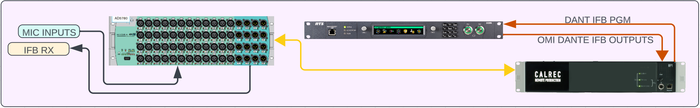



The essential functions and signal flow of the RP-1, while sometimes circular and confusing, can be clarified by thinking through the purpose of the unit described above and then following a line drawing placed later in this document to confirm signal flow.

*See the image below for a basic line drawing of the signal flow outlined above and further described below.*

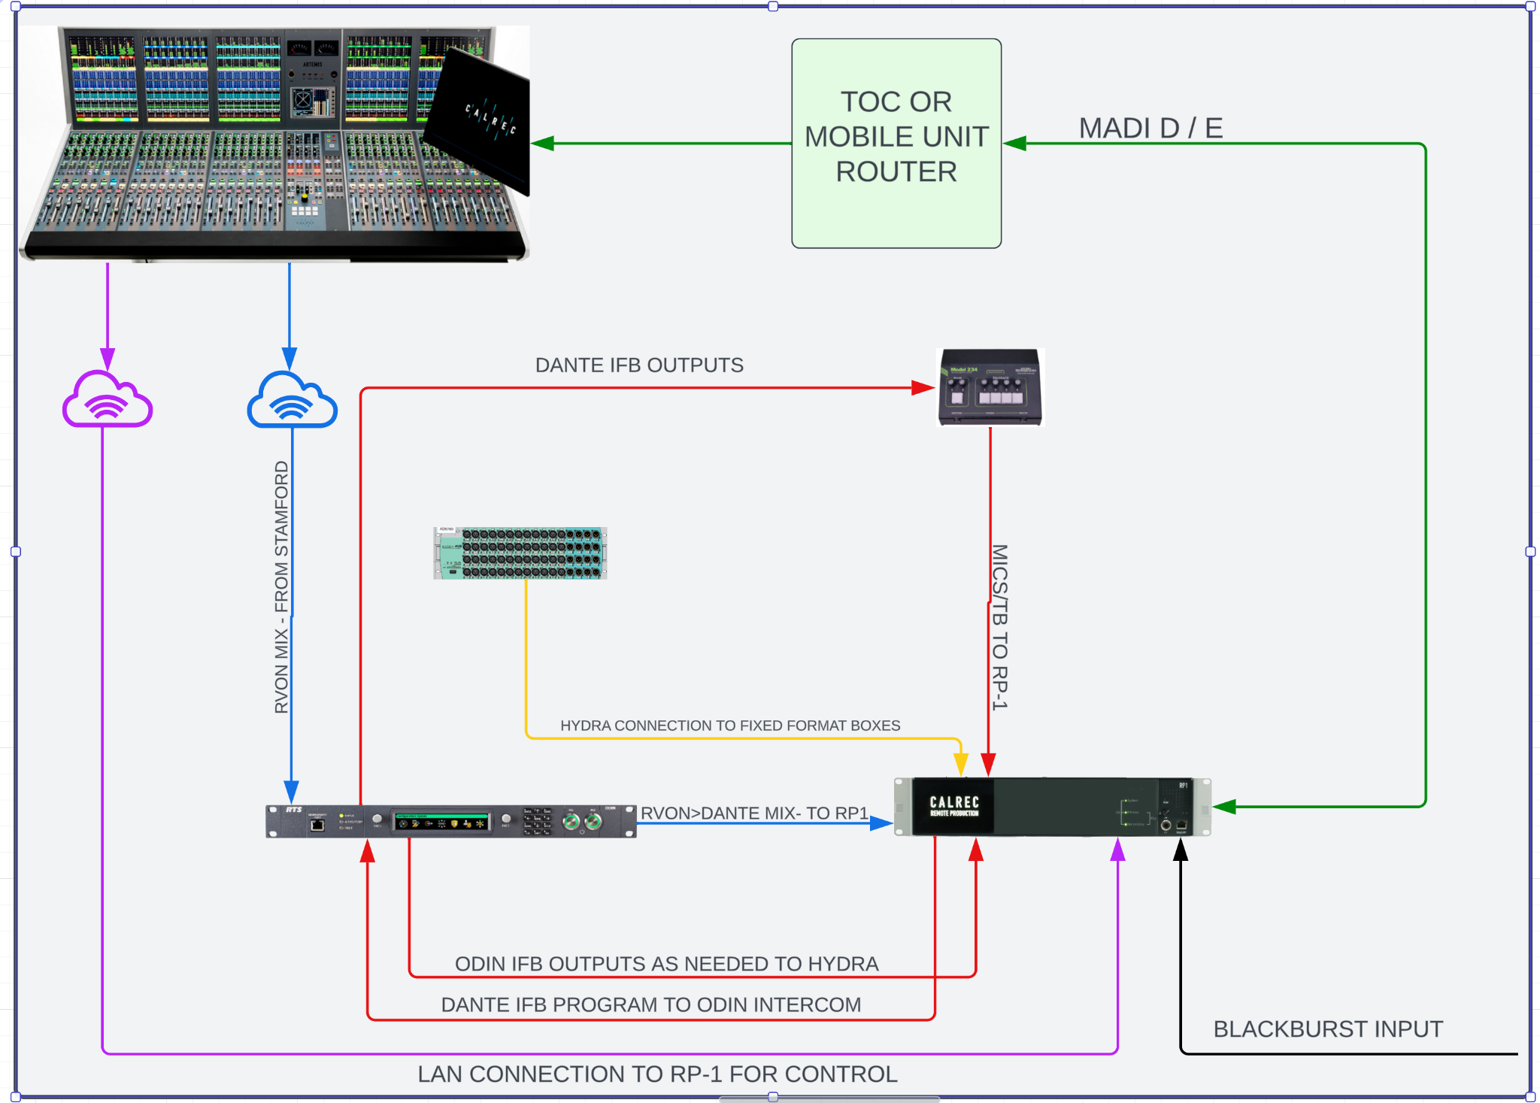



**VENUE RESPONSIBILITIES REGARDING RP-1**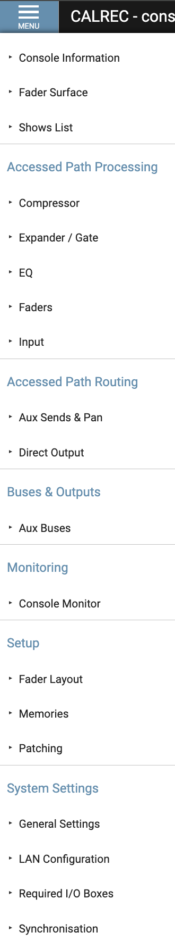

All basic builds, routing, and setup for the RP-1 units have been pre-configured and while changes are expected please follow the audio workbooks for each venue before facilitating or changing any routing. Each audio workbook describes and details all routes and configurations as they are currently known. Most changes to any configuration of the units should be handled by the A1 on the production, but if facilities need to be tweaked or adjusted please make Glenn Stilwell, Karl Malone, or Mike D aware of the changes so they can help facilitate.

All menus within the RP-1 GUI will look and feel very similar to anyone familiar with Calrec consoles. Navigation of the different menus can be found by clicking the MENU button in the top left of the GUI web page (*shown on the left)*. Most important are the FADER LAYOUT, PATCHING, AUX SENDS AND PAN, INPUT, FADER SURFACE, SYNCHRONIZATION and MEMORIES menus.

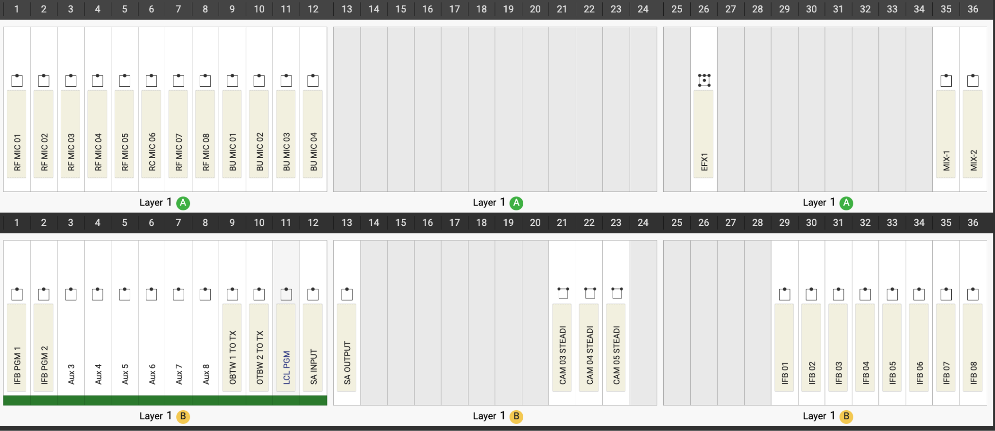

The Fader Layout menu is used to ADD a fader to the RP-1 virtual surface, this is done by navigating to the menu and then selecting and open and available fader position and using the + NEW icon at the bottom of the page to create a new MONO, STEREO, or 5.1 fader. Please note that in many of the configurations for the MiCo Olympics all DSP channels have been used so no new channels can be added to the RP-1.

The Patching menu is used to patch inputs and outputs from and to the Dante, Hydra, or Madi IO as well as patch signals into faders created in the Fader Layout Menu. For the venue operators the main function of this menu will be to correct or change the input source set to a fader. As a rule of thumb please **DO NOT** for any reason unpatch the signals being sent to the RP-1’s MADI cards; this would directly affect transmission and any changes would need to come from the production’s A1.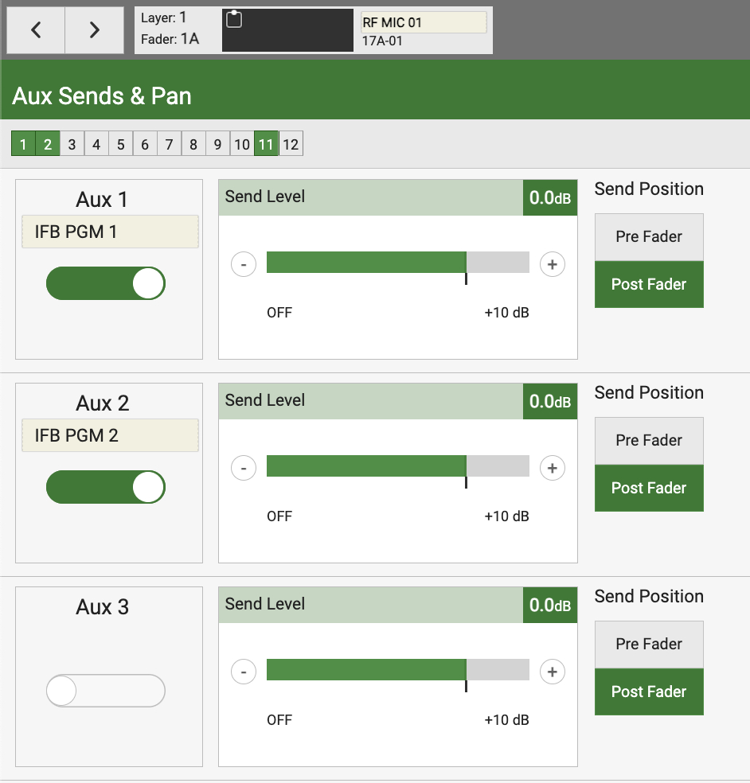

The Aux Sends and Pan menu is used to send RP-1 inputs to the aux bus outputs and create mixes generated by the RP-1. Each fader is selected individually at the top left of the WEB GUI and by selecting the toggle switch under each aux will send that signal source to the bus output. The use of all aux buses is detailed within the audio workbook for each venue and all sources and mixes should already be created, but new signals and corrections to existing mixes can be made here. Please do not under any circumstance send audio to auxiliary busses PRE-FADER, this is difficult to find if that routing causes any issues.****

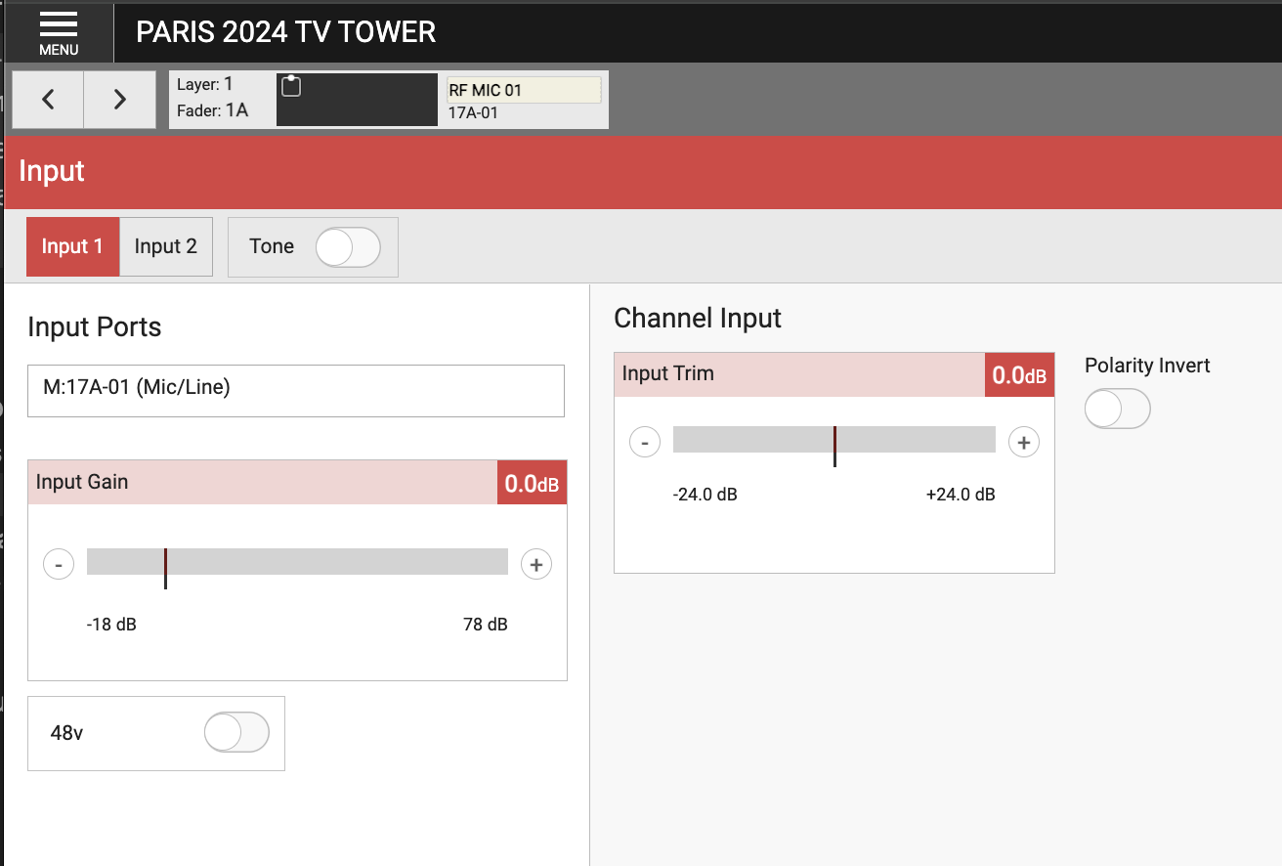



The Input menu will be the most used tool for audio operators at each venue, this is where input gain / trim can be set or changed, +48v phantom power can be applied, and selecting tone for the fader can be done. These settings are displayed and accessible on a per fader basis, navigating between faders can be done using the arrows at the top left of the GUI or by clicking the label to right of that and then selecting the desired fader in the subsequent menu.

While most of the configuration on the input screen will be done by each production’s A1, test signals will need to be generated by the on site audio team when doing internal check-ins without the production A1. Once the router from the TOC or Mobile Unit is configured for transmission please NEVER un-route or change the RP-1 source signals in the router or signals to the RP-1’s Madi outputs cards. To test transmission with BOC or internally refer to the expected channel mapping in each audio workbook and source by source individually set TONE to each associated RP-1 input.

In many cases there are signals such as PFL, Monitor Outputs, and camera feeds or other superfluous signals that are set to TX from the RP-1 - **do not break these routes** - if a TX channel does not have an RP-1 fader associated with it - simply skip it during internal and BOC checks, since these signals are not going directly to air the production’s A1 who is receiving all signals can sign off on transmission and signals that cannot be checked directly from the RP-1.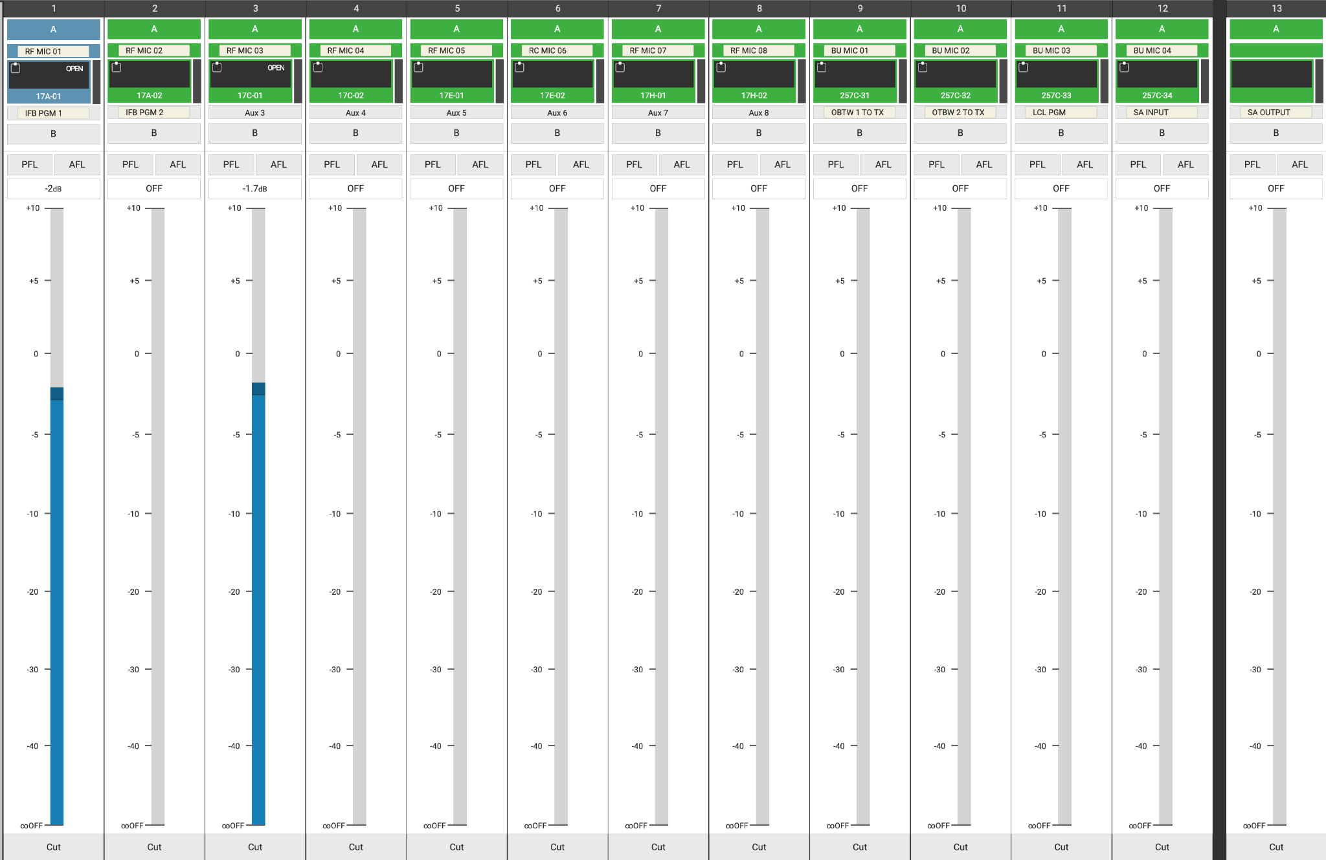

The Fader Surface menu gives local control of the faders on the RP-1’s surface and can be used to open and close sources to test auxiliary output mixes since all sources are sent to the aux buses POST FADE. Please note that faders do not need to be opened to check transmission as all sources are sent to transmission using pre-fader direct outputs. The blue bar in the center of each fader represents the faders level, to adjust the level simply click on a fader and drag the mouse up or down. When a host console takes control of an RP-1 unit the host console will block local control as adjusting local faders when a host console is paired would cause faders on the host console to open without the A1 doing so.

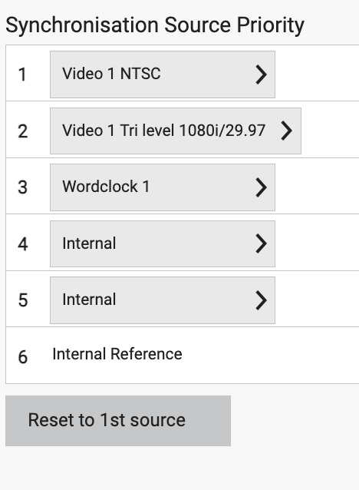

The Synchronization menu will need to be navigated to once a valid sync source is provided to the RP-1’s VID1 sync input after which sync priority must be set. Set the sync priority (VID1 input source>Workclock> then internal for the rest) and then select the reset to 1st source button which will change the sync source and lock to the 1st valid signal found in the priority list - if the 1st priority signal is not locked the RP-1 will show a yellow warning in the system status on the top right of the web GUI. Often, if a sync source powers down or takes a hit the sync for the RP-1 bay need to be reset by just resetting the source because it will not reset back up the priority list in case of a sync generator error.

The Memories menu is where the default configuration for each venue is saved if any changes are inadvertently made and a set up needs to be recalled. The RP-1 follows the same file structure as larger Calrec systems. Shows are made and Memories exist within each show - on each RP-1 a unique show has been created for each venue at the MiCo 2026 Games, Memories and configurations can be saved within that structure. These resources will mainly be handled by the production A1 but can be recalled as needed to the shipped state after initial configuration that was completed in Monroe. 

**MISC NOTES**

At some studios and venues there are two RP-1 units functioning as a primary and secondary unit. In this case the card slots in the second unit should be referred to as F, G, and H. At these locations each unit is fully redundant with its primary and secondary hydra boxes and hubs.